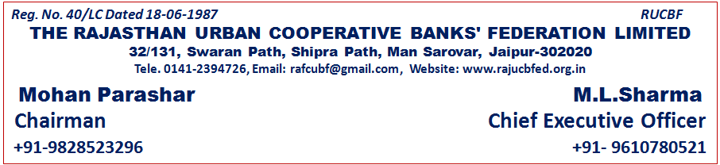
orZeku lapkyd e.My ¼31-03-2026 dh fLFkfr½
dz-la- | uke | dk;kZy; dk irk | QSMjs'ku esa in |  | eksckbZy uaacj
1 | Jh eksgu ikjk'kj | v/;{k] tkykSj ukxfjd lgdkjh cSsad fy-] tkykSj | v/;{k |  | 9828523296
2 | Jh gjxksfoUn tSu | v/;{k] ckjka ukxfjd lgdkjh cSad fy-] ckjka | dk;Zokgd mik/;{k |  | 9414191146
3 | Jh v'kksd dqekj fla?koh | v/;{k] ckyksrjk vjcu dks&vkWijsfVo cSad fy-] ckyksrjk | lapkyd |  | 9413993250
4 | Jh rkSlhQ gqlSu | v/;{k] mn;iqj vjcu dks&vkWijsfVo cSad fy-] mn;iqj | lapkyd |  | 9829538659
5 | Jherh uafnrk jkt | v/;{k] jkty{eh efgyk vjcu dks&vkWij- cSad fy-] t;iqj | lapkyd
6 | Jh jktss'k d`".k fcjyk | v/;{k] dksVk ukxfjd lgdkjh cSad fy-] dksVk | lapkyd |  | 9829035812
7 | Jh foosdkuUn ik.Ms | v/;{k] HkhyokM+k vjcu dks&vkWijsfVo cSad fy-] HkhyokM+k | lapkyd |  | 9829046915
8 | Jh ohj fnXosUnz jk.kk | v/;{k] /kkSyiqj vjcu dks&vkWi- cSad fy-] /kkSyiqj | lapkyd |  | 9414026900  9829189678
9 | Jh 'ks[kj dqekj | v/;{k] jktlean vjcu dks&vkWijsfVo cSad fy-] jktlean | lapkyd |  | 9929595596  8003992101
10 | Jh lR;s'k 'kekZ | v/;{k] cwanh vjcu dks&vkWi- cSad fy-] cwanh | lapkyd |  | 9419917824
11 | Jh ftusUnz tSu | v/;{k] ikyh vjcu dks&vkWijsfVo cSad fy-] ikyh | lgo`r lapkyd |  | 9414122927
12 | Jh iznhi tks'kh | v/;{k] lhdj vjcu dks&vkWijsfVo cSad fy-] lhdj | lgo`r lapkyd |  | 8432581700
13 | Jh jkgqy ikjhd | v/;{k] pw: vjcu dks&vkWijsfVo cSad fy-] lknqZyiqj | lgo`r lapkyd |  | 9610002746
14 | Jh d`".kkorkj 'kekZ | v/;{k] nkSlk vjcu dks&vkWijsfVo cSad fy-] nkSlk | lgo`r lapkyd |  | 9414083250
15 | Jh j.kohj flag pwaM+kor | izca/k funs'kd] fn jktLFkku LVsV dks&vkWijsfVo cSad fy0]t;iqj | lapkyd |  | 9414455920
16 | Jh ,u-,l- Mkch | izca/k funs'kd] ekm.V ukxfjd lgdkjh cSad fy-] fljksgh | fo'ks"k vkeaf=r lnL; |  | 9414152382
17 | Jh lquhy ikespk | izca/k funs'kd] fQuxzksFk dks&vkWijsfVo cSad] t;iqj | fo'ks"k vkeaf=r lnL; |  | 9829221141
QSMjs'ku LVkQ
1 | Jh ,e- ,y- 'kekZ | eq[; dk;Z- vf/kdkjh] fn jkt-vjcu dks&vkWi- cSaDl QSMjs'ku fy- |  | lnL; lfpo | 9610780521
2 | Jh izgykn dqekj xqIrk | izca/kd] fn jktLFkku vjcu dks&vkWijsfVo cSaDl QSMjs'ku fy- |  | izca/kd | 9414920926  8949574117
3 | Jherh vpZuk 'kekZ | izca/kd&rduhdh] fn jkt- vjcu dks&vkWi- cSaDl QSMjs'ku fy- |  | izca/kd&rduhdh | 9468866126
4 | Jh Hkqous'k vxzoky | ,DthD;wfVo] fn jkt- vjcu dks&vkWi- cSaDl QSMjs'ku fy- |  | ,DthD;wfVo | 9314871232

